TECHNICAL NOTES ENEL300
Author: Philipp Hof, Draft, 26APR12

Introduction
The ATmega8 microcontroller supports In-System Programming (ISP).
An open-source tool to program or upload the firmware into the microcontroller is AVRDUDE. AVRDUDE supports a wide range of programmers. The simplest one to use is the parallel port. A driver to access the parallel port is installed in the Digital Systems Laboratory (XP machines) and Electronics Laboratory.
Another choice is the departmental USB-JTAG programmer. It is only required when no parallel port is available. Due to the requirements of having administrator privileges on Windows it is unavailable in our laboratories but can be used on your own notebook at your own risks.
Some of the required files can be found here, including an example with a makefile: V:\MSTdev\WinAVR\avr-tools-r2012
(Mapping of the V:\ drive to elecapp)
Others or the latest versions can be downloaded from here:
- AVRDUDE: http://helix.air.net.au/helix/index.php/avrdude-and-ftdi-232h/
- Atmel FT2232 ISP programmer (an alternative to AVRDUDE): http://wesche.we.ohost.de/Homepage/Version_3/index.php?section=PC_Delphi_FT2232_AtmelISP.html
- FTDI device drivers: http://www.ftdichip.com
- libusb-win32 (required for AVRDUDE):
  - http://sourceforge.net/apps/mediawiki/libwdi/index.php?title=Main_Page
  - http://sourceforge.net/apps/trac/libusb-win32/wiki
The C compiler provided in the laboratories is WinAVR. It is also part of the avr-tools-r2012 folder. AVR Studio is shipped with avr-gcc as well: http://www.atmel.com/microsite/avr_studio_5/default.aspx

Powering the Microcontroller
The voltage from 4 x AA Alkaline batteries may exceed the maximum voltage of the ATmega8 microcontroller. At minimum a series diode i.e. 1N4001 is required to reduce the voltage and also to prevent damage against inverted polarisation.
Example (without an on-off switch):
The departmental USB-JTAG converter operates at 3.3V. Hence the use of a 3.3V regulator and a protection diode in series is highly recommended although not strictly required when current limiting resistors are used on all the programming lines. The following voltage regulator MCP1700-3302E/TO in a TO-92 through hole package will be available for this project on demand. Since it maximum input voltage is only 6V a series diode as mentioned above is required for alkaline batteries and recommended for Ni-HM batteries.
Voltage Regulator: http://www.microchip.com/wwwproducts/Devices.aspx?dDocName=en010642
Note: Do not connect the H-bridge to the above V+. When starting both motors the battery voltage may momentarily drop significantly. Having a large enough capacitors, as shown above, may prevent resetting the microcontroller. The diode further prevents discharging the capacitor through the voltage drop over the batteries.
Further the power rails for the H-bridge must be designed to absorb the generated voltage spikes from the motors or they may damage the microcontroller. The simplest solution here is connecting the H-bridge on short tracks and leads directly to the batteries (giving up protection against inverted polarisation). Additional capacitors are still required.
High capacity AA Ni-HM batteries are recommended. They have a low internal resistance through most of their discharge cycle and hence a flatter discharge curve than alkaline batteries.

In-System Programming Connections
The ISP programming lines on the ATMEGA8 are MISO (Master In Slave Out), MOSI (Master Out Slave In), SCK (Clock) and RESET.
These are the minimal connections required for the programmer to work. Please refer to the ATMEGA8 datasheet in regard to AVCC. Decoupling capacitors need to be placed as close as possible to the power ports. The pull-up resistor on the reset pin must not be lower than 10k.

Parallel Port Interface
Recommended parallel port interface with current limiting resistors:

FT2232D USB to JTAG module
The datasheet for the USB to JTAG module can be found here: http://ecewiki.elec.canterbury.ac.nz/mediawiki/images/6/6a/USB_to_Jtag3.pdf
Please use series resistors similar to the parallel port interface above, increasing R1 to 10k. Keep the cable you produce as short as possible.
Interface to P2 (ARM JTAG) connector on the USB to JTAG interface.

PINOUT for AVRDUDE
MOSI = 5  SCK = 9  RESET = 7  MISO = 13  GND = 4 | 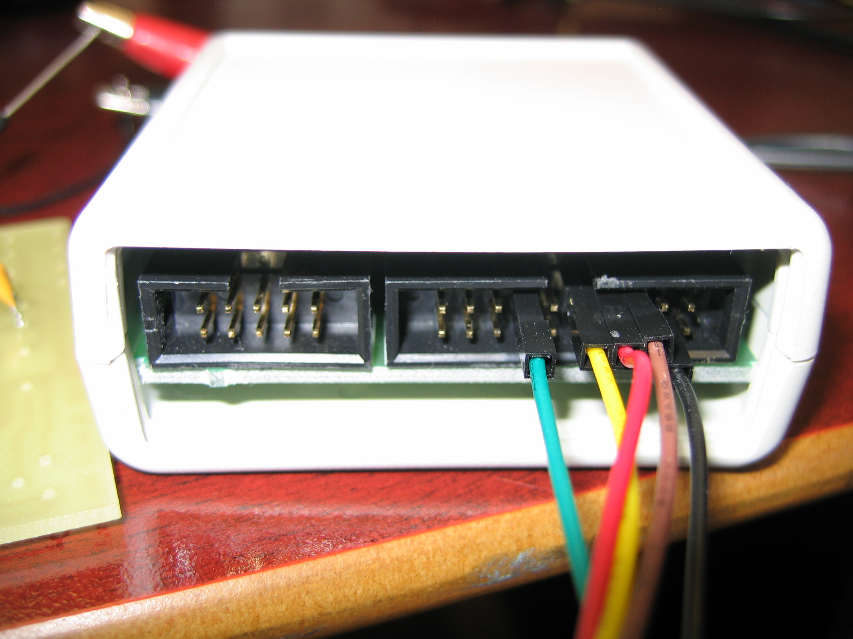  PIN 1  PIN2

PINOUT for FT2232 ATMEL ISP programmer
Same as above except for:
RESET = 3

Using avr-gcc
Copy from V:\MSTdev\WinAVR\avr-tools-r2012 the folder ATMEGA8_EXAMPLE to your J: drive avoiding spaces in path and file names.
Double click on avr-gcc-tools-r2012.bat. This will open a prompt to use WinAVR from the network. On computers with WinAVR installed locally (ELEC Lab & DSL) you can also run local_prompt.bat, which just opens a command prompt (no path settings). It is there for convenience. The local compiler will run faster.
Adapt main.c to your needs. Compile it by typing make on the command prompt.
Have a look at the makefile with a text editor and adapt it to your needs.
You don’t need to use make. You can invoke the compiler directly on the command prompt if you prefer to work like that i.e. running in C99 standard type:
avr-gcc -g -Wall -mmcu=atmega8 -std=c99 -Os -I. file1.c file2.c -o output.elf
To produce a .hex file type:
avr-objcopy -O ihex -R .eeprom output.elf output.hex
You can also use AVR Studio on you own computer. It will do it all for you.

Uploading the Firmware (Parallel Port)
Open the command prompt as described above. Connect power to your board. (If you are connecting your board the first time to power it is advisable to limit the current from the power supply to i.e. 100mA.)
Type:
avrdude -p m8 -P lpt1 -c sp12
where lpt1 is the parallel port, sp12 the type of programmer, m8 the device.
If the communication was successful you should see the following output:
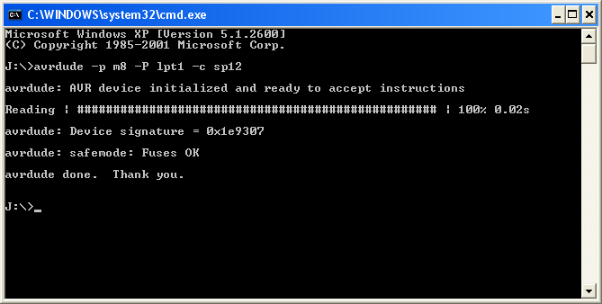
You can now continue to upload your firmware by using the batch file load-pp.bat i.e for main.hex:
load-pp main

Writing Fuses
The fuses allow you to change the clock frequency, enable brown out detection (BOD is recommended) and more. Care must be taken when programming the fuses. Programming the wrong fuse bits may render your device inoperative. Communication errors while writing the fuses may result in the same.
Test yourself: Read/download the default fuse setting from the device first and compare them with the ATMEGA8 datasheet to see if they make sense. If not leave them alone.

Using the FT2232 USB to JTAG module

Software requirements:
You will need administrator rights to install the required software.
INSTALLING ANY SOFTWARE IS AT YOUR OWN RISK.
Download and install the FTDI driver as a setup executable from www.ftdichip.com. (Not strictly required for AVRDUDE.)
Connect the module to the computer. It should now be recognized. This is all that is required for the ‘FT2232 Atmel ISP Programmer’ from A Weschenfelder. Please go to that section if you intent to use this programmer only.
AVRDUDE requires libusb-win32.

libusb-win32
libusb-win32 has an installer that allows you to install the driver as a filter driver for a particular USB device. Install the filter driver for VID:0403 (FTDI), PID:6010, USB Serial Converter A. The installer executable itself is in the bin directory. Use x86 for 32-bit machines and amd64 for 64-bit machines (including Intel). Please read the online documentation first.
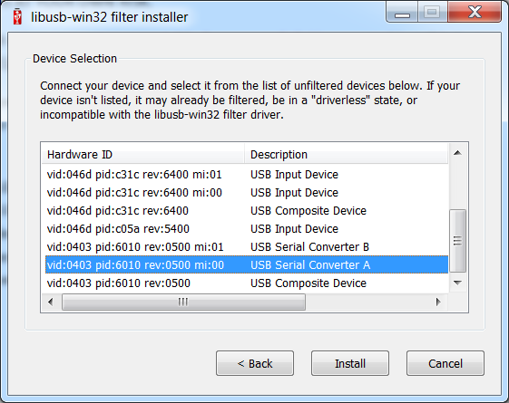

libusb-win32 with Zadig
Zadig can do the above and also replace the existing driver or install a new driver if the manufacturer’s driver is not available on the machine. Please read the online documentation first. Make sure you selected libusb-win32!
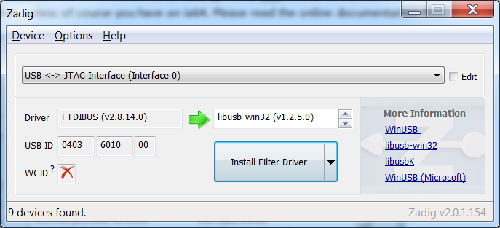

FT2232 Atmel ISP Programmer
Select as a device name ‘JTAG Interface A’. Under settings increase the clock divider if there are errors while flashing the device. I had to set it to 150 on my machine. ‘Write Flash Content’ to upload your firmware to the microcontroller.
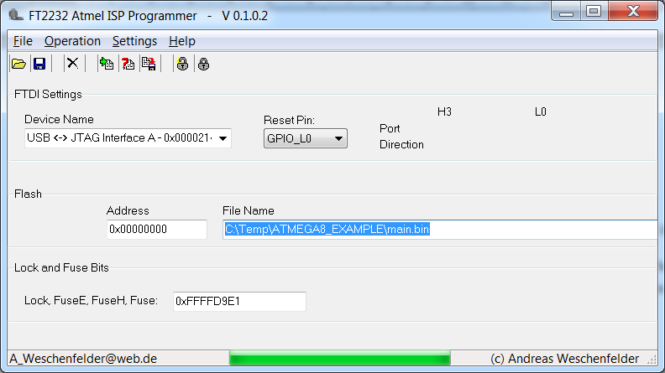 | 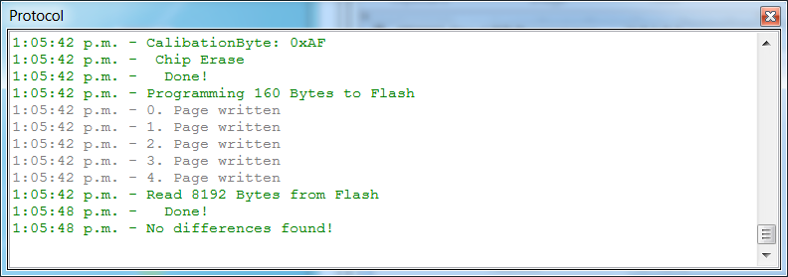

AVRDUDE 5.11 patch 7729
You require AVRDUDE 5.11 patch 7729 for this to work. (Available in avr-tools-r2012)
Try on the command prompt:
avrdude -p m8 -c avrftdi
If the communication was successful you should see this:
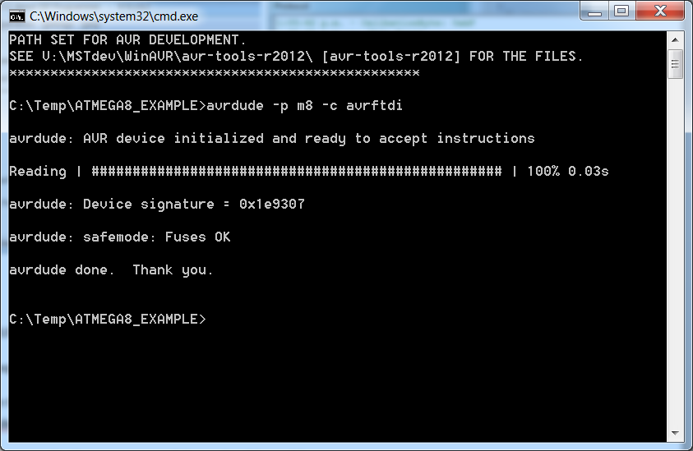
You can now continue to upload your firmware by using the batch file load-avrftdi.bat i.e for main.hex:
load-avrftdi main

